|  |  |  |  |
| --- | --- | --- | --- |
| Number of states | width | height | Name |
| 17,857 | 512 | 512 | AR0201SR |
| 37,884 | 512 | 512 | AR0331SR |
| 2,054 | 49 | 49 | arena |
| 2,445 | 65 | 81 | den312d |
| 28,178 | 256 | 257 | den520d |
| 7,461 | 162 | 141 | ht_chantry |
| 8,959 | 133 | 270 | ht_mansion_n |
| 14,784 | 194 | 194 | lak303d |
| 10,021 | 251 | 180 | lt_gallowstemplar_n |
| 13,241 | 194 | 194 | ost003d |
| 34,020 | 642 | 578 | w_woundedcoast |
| 24,311 | 281 | 209 | arena2 |
| 5,214 | 359 | 252 | brc300d |
| 15,788 | 528 | 209 | brc200d |
| 25,645 | 391 | 388 | brc201d |
| 29,882 | 384 | 639 | brc101d |
| 28,963 | 257 | 261 | brc000d |
| 31,023 | 512 | 492 | brc100d |

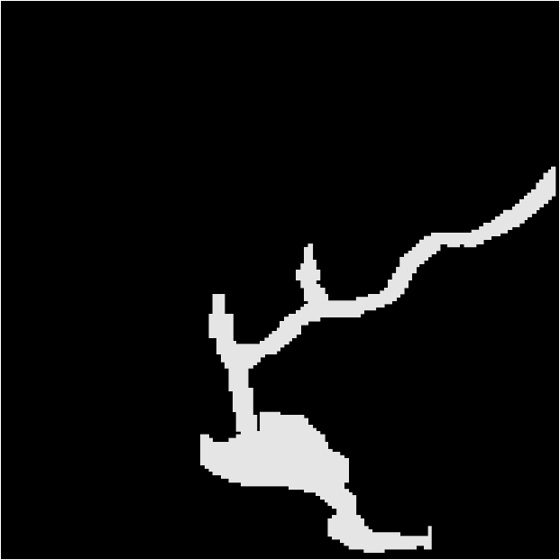AR0201SR

AR0331SR



Arena

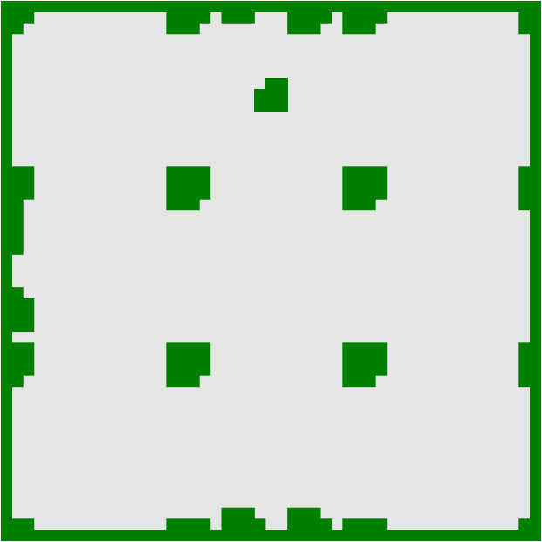

den312d



den520d

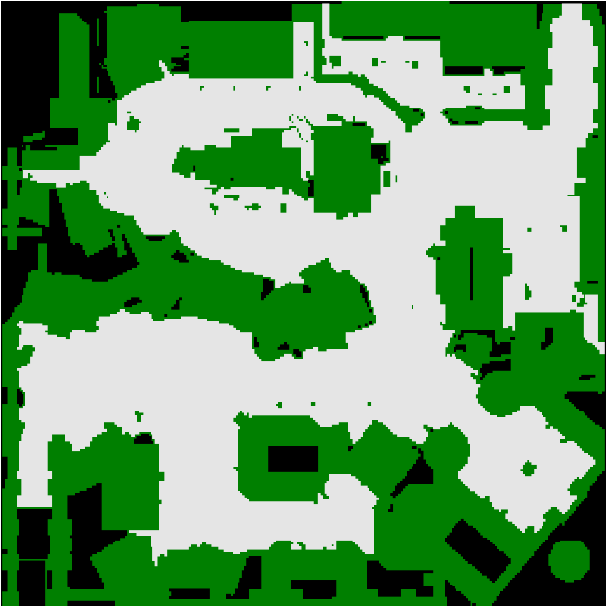

Ht_chantry

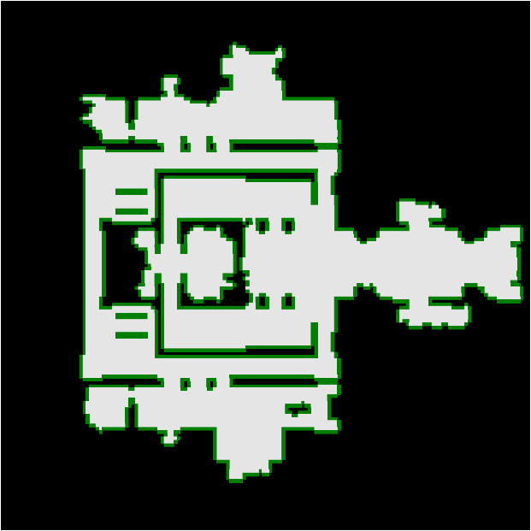

Ht_mansion_n

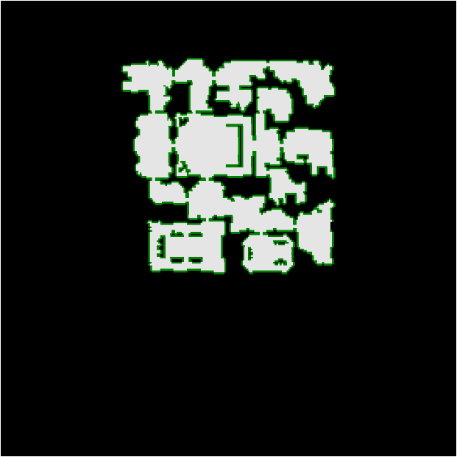

Lak303d

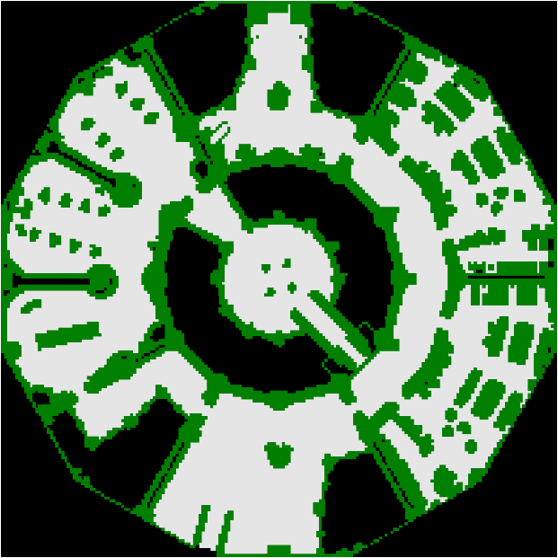

lt_gallowstemplar_n

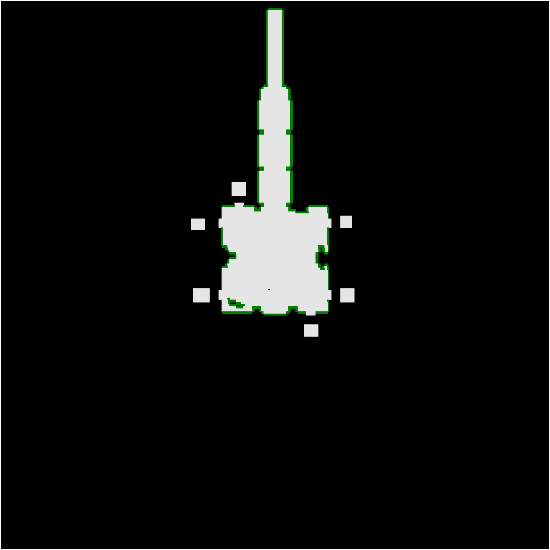

ost003d

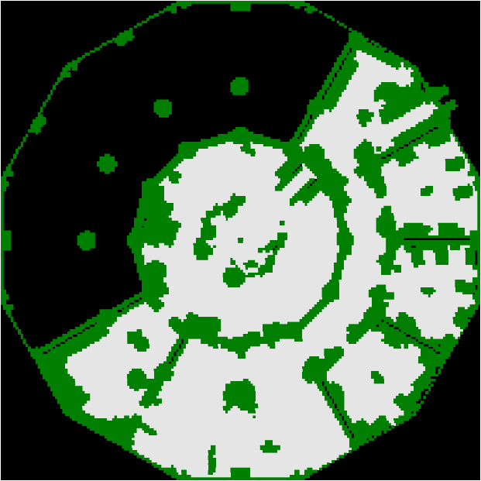

w_woundedcoast

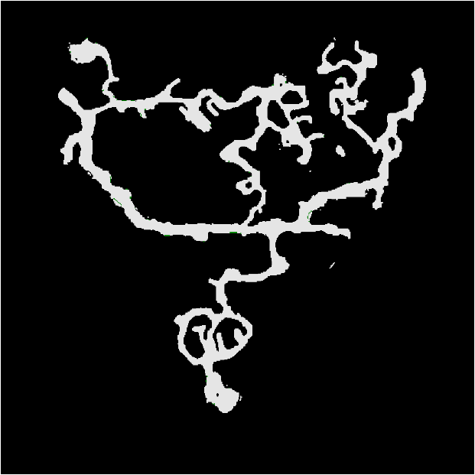

arena2

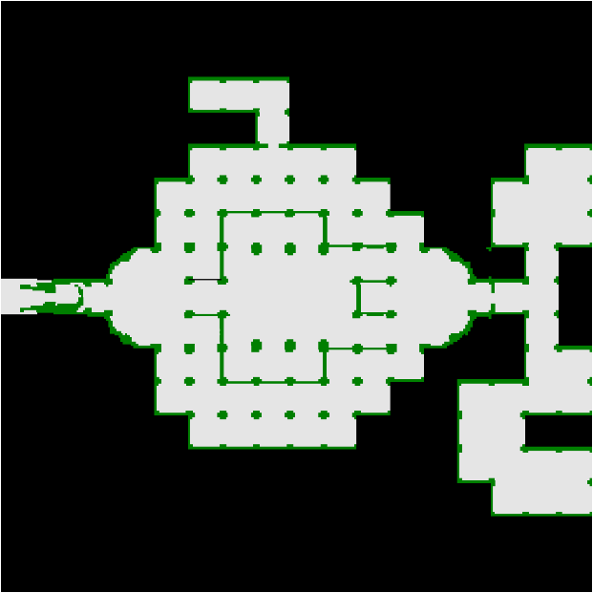

brc300d

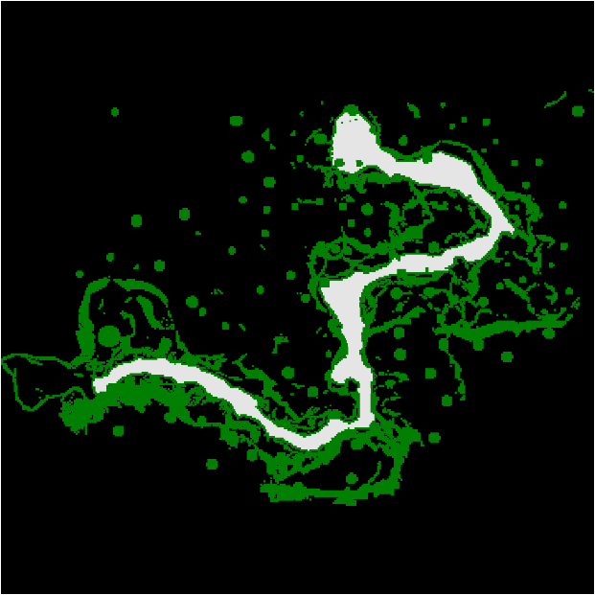

brc200d

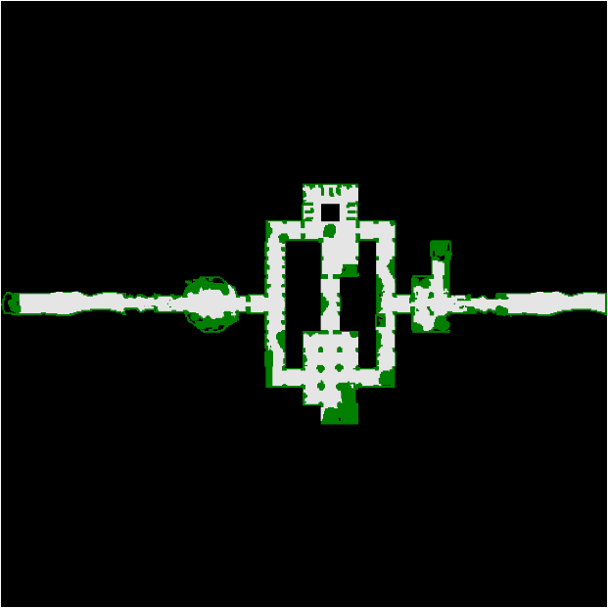

brc201d

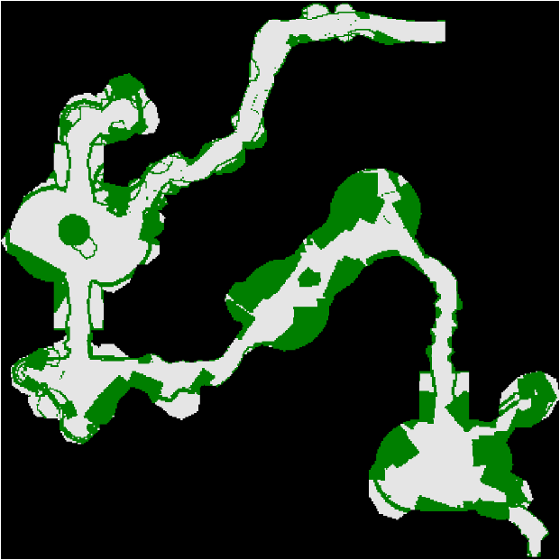

brc101d

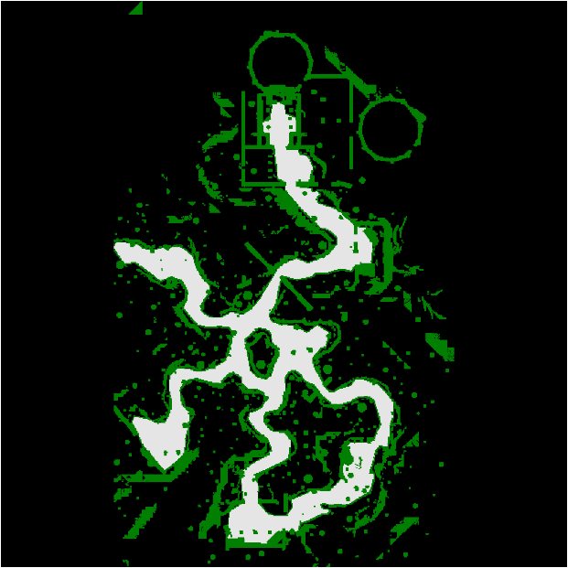

brc000d

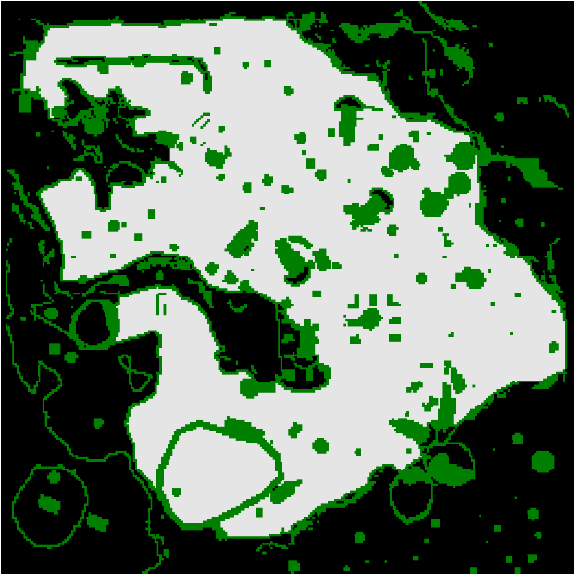

brc100d

